Description of courses which address GENDER
- Political Science
M.A. (Pol Sci) Sem IV P -XX
- Home Science
- B.A. Semester VI

BFA
- B.F.A. Semester III P-IV,V,VI
- B.F.A. Semester IV P-IV,V,VI
- B.F.A. Semester V P-IV,V,VI
- B.F.A. Semester VI P-IV,V,VI
- B.F.A. Semester VII P-IV,V,VI
- B.F.A. Semester VIII P-IV,V,VI
- Bachelor of Design
- Bachelor of Design (Semester II) Fashion and Textile Designing
- Bachelor of Design (Semester III) Fashion and Textile Designing
- Bachelor of Design (Semester IV) Fashion and Textile Designing
- Bachelor of Design (Semester IV) Interior Design
- Bachelor of Design (Semester VI) Fashion and Textile Designing
- Punjabi
- B.A./ B.Sc./ B.Com./B.B.A. Semester I
- B.A./ B.Sc./ B.Com./B.B.A. Semester II
- B.A./ B.Sc./ B.Com./B.B.A. Semester III
- B.A./ B.Sc./ B.Com./B.B.A. Semester IV
- B.A./ B.Sc./ B.Com./B.B.A. Semester V
- B.A./ B.Sc./ B.Com./B.B.A. Semester VI
- El. Punjabi
- B.A.Semester I
- B.A.Semester II
- B.A.Semester III
- B.A.Semester IV
- B.A.Semester V
- B.A.Semester VI
- English
- B.A./B.Sc./B.Com Semester I
- B.A./B.Sc./B.Com Semester II
- B.A./B.Sc./B.Com Semester III
- B.A./B.Sc./B.Com Semester IV
- B.A./B.Sc./B.Com Semester V
- B.A./B.Sc./B.Com Semester VI
- B.A. (English Hons) Semester V
- M.A. Semester I
- M.A. Semester II
- M.A. Semester III
- M.A. Semester IV

- Hindi
- B.A. Semester IV
- M.A. Semester III P-XI
- M.A. Semester III P-XII
- Fashion Designing
- B.Voc (FT) Semester I P-VI
- B.Voc (FT) Semester II P-VI
- M.Sc. (FD) Semester I P-I
- M.Sc. (FD) Semester I P-II
- M.Sc. (FD) Semester II P-I
- M.Sc. (FD) Semester IV P-I, II

- Sociology Semester III
- B.Voc (MHC) Semester VI P-I

Proofs of courses which address Gender related topics

M.A. Political Science (For Colleges) Semester – IV PAPER XX
POLITICS IN SOUTH ASIA
Time: 3 Hours Max. Marks: 80
Instructions for the Paper Setters:-
Eight questions of equal marks (Specified in the syllabus) are to be set, two in each of the four ections (A-D). Questions may be subdivided into parts (not exceeding four). Candidates are required to attempt five questions, selecting at least one question from each Section. The fifth question may be attempted from any Section.
Section - A
Approaches to the Study of Politics of Developing Countries with Special Reference to South Asia
Impact of Colonialism and Anti-Colonial Liberation Movements on the Politics of South Asian Countries
Nature of Post-Colonial States in South Asia States
Section - B
Issues of State & Nation-Building in South- Asia.
Political Elites in South Asia with Special Reference to India & Pakistan. Ethnicity in the Politics of South Asian States
Section - C
Human Development Indices in South Asia
Globalization and its Impact on the Politics of South Asian States Governance in South Asia: An Overview
Section -D
Separatism & Terrorism in South Asia.
Issues of Human Rights and Civil Society.
Women‟s Movements in South Asia with Special Reference to India, Pakistan & Bangladesh.

B.A./B.Sc. (Semester System) (12+3 System of Education) (Semester–VI) (Faculty of Sciences)
SEMESTER–VI HOME SCIENCE
FOODS AND NUTRITION & CHILD DEVELOPMENT–II (THEORY)

Time: 3 Hrs. | Max. Marks: 100
Periods: 6 Hrs./week | Theory Marks: 60
 | Practical Marks: 40
Instructions for the Paper Setters:

The question paper will consist of five sections A, B, C, D & E. Section A, B, C, D will have two Questions from the respective sections of the syllabus and will be of 12 marks each. Section E will consist of short type questions covering the entire syllabus uniformly and will be of 12 marks.

Instructions for the Candidates:
Candidates are required to attempt one question each from section A, B, C, D and section E is compulsory

Section–A
Food Adulteration:
Definition
Common Adulteration Food standards

Concept of balanced diet.

Classification of food based on the five/seven food groups. Principles of Meal planning.
Section–B

Therapeutic Diets & Modification of Normal Diets:
Principles of Therapeutic Diets
Concept of Soft, Bland, Liquid Diets with examples.

Therapeutic diets in the following conditions with principles involved:
Fever Constipation Diarrhea
High Blood Pressure/Hypertension

Diabetes Mellitus

Social Development:
Stages of Social Development Pattern of Social Development

Section–C

Role of Family and School in the Development of the Child.

Play:
Significance of Play Types of Play
Play Materials/Equipment required for various age group.
Common Behavior Problems and their Remedies–Bed Wetting, Thumb Sucking, Nail Biting, Temper- Tantrums.
Section–D
Pregnancy:
Signs and Symptoms of Pregnancy
Discomforts
Complications
Care During Pregnancy
Methods of Family Planning in Brief
Pre Natal Development:
Stages of Pre Natal Development
Factor Affecting Pre Natal Development

Feeding of the Infant
Importance and Process of Breast Feeding Bottle Feeding
Weaning
Important Weaning Foods Importance of Weaning

Bachelor of Fine Arts (Painting) (Semester-III) Paper–IV: PORTRAIT (Practical)
Construction of skull, planes, masses of the head, understanding and creating details such as the eyes, the mouth, the nose etc., bust from different angles and eye levels, adding of details, and finishing. Character of the solid shapes of different parts and their modeling.
Bachelor of Fine Arts (Painting) (Semester-III) Paper–V: LIFE DRAWING (Practical)
Study from life model to develop understanding of the human structure; volume in perspective and foreshortening proportion of male and female, rhythmic curves as uniting factors in all parts of the body; balance of parts, study of anatomy; various media.
Bachelor of Fine Arts (Painting) (Semester-III) Paper–VI: COMPOSITION PAINTING (Practical)
The two dimensional surface and its structural possibilities elements of plastic expression related to the concepts of space and form and use of colors and textural values; form and contents; compositional exercises based on objects, forms and animals; various media. Out door or indoor selection of spot, picture frame observation and study of nature in its variable forms and textures, addition and elimination, simplification, eye levels and perspective, balance and rhythms to be used in composition.

Bachelor of Fine Arts (Painting) (Semester-IV) Paper–IV: PORTRAIT (Practical)
Students shall work on portrait study on different age from life models groups showing characteristics, resemblance, proportions, features etc., and develop the skills of handling and treating colors in various ways suitable for portraiture. Emphasis shall be on developing the concepts of drawing.
Bachelor of Fine Arts (Painting) (Semester-IV) Paper–V: LIFE DRAWING (Practical)
Students shall work on figure from different age groups showing their characteristics, features and proportions. They should deal in different planes of the body, chiaroscuro effects, body perspective and foreshortening etc.
Emphasis shall be on developing the concepts of drawing.

Bachelor of Fine Arts (Painting) (Semester-IV) Paper–VI: COMPOSITION PAINTING (Practical)
This studio practice is focused on observe and interpret the visible world in two dimensional forms through painting, crossing over a wide range of mediums and dealing with a variety of issues-the personal, formal, social etc.
Students are encouraged to create a working process that incorporates technical skills and adventurous thinking and experimentation with space and color.

Bachelor of Fine Arts (Painting) (Semester – V) Paper – IV: PORTRAIT (Practical)
Construction of skull, planes, masses of the head; editing details such as the eyes, the mouth, the nose etc.Character of the solid shapes of different parts and their modeling.Studying various features along with exercising various expressions in facial and muscular forms.

Bachelor of Fine Arts (Painting) (Semester – V) Paper – V: LIFE DRAWING (Practical)
Study from life model to develop understanding of the human structure ; volume in perspective and foreshortening proportion of male and female, rhythmic curves as uniting factors in all parts of the body; balance of parts, study of anatomy; various media; emphasis on delineation of character, various expressions and composition of figure in different settings and environment.
Bachelor of Fine Arts (Painting) (Semester – V) Paper – VI: COMPOSITION PAINTING (Practical)
The two dimensional surface and its structural possibilities elements of plastic expression related to the concepts of space and form and use of colors and textural values; form and contents; compositional exercises based on objects, forms and animals; various media.
Exercises based on compositional studies of objects (singular and in groups), consideration of space in composition, study on locales or surroundings.
Analysis of compositions in paintings along with the use of colours and textures

Bachelor of Fine Arts (Painting) (Semester – VI) Paper – IV: PORTRAIT (Practical)

Students shall work on portrait study on different age from life models groups showing characteristics, resemblance, proportions, features etc., and develop the skills of handling and treating colors in various ways suitable for portraiture. Emphasis shall be on developing the concepts of drawing.

Bachelor of Fine Arts (Painting) (Semester – VI) Paper–V: LIFE DRAWING (Practical)

Students shall work on figure from different age groups showing their characteristics, features and proportions. They should deal in different planes of the body, chiaroscuro effects, body perspective and foreshortening etc.
Advanced study from life model to develop a volume, conception, human structure equilibrium and locomotion in various mediums.
Emphasis shall be on developing the concepts of drawing.

Bachelor of Fine Arts (Painting) (Semester – VI) Paper – VI: COMPOSITION PAINTING (Practical)

This studio practice is focused on observe and interpret the visible world in two dimensional forms through painting, crossing over a wide range of mediums and dealing with a variety of issues-the personal, formal, social etc.

Bachelor of Fine Arts (Painting) (Semester – VII) Paper – IV: PORTRAIT (Practical
Students shall work on portrait study on different age from life models groups showing characteristics, resemblance, proportions, features etc., and develop the skills of handling and creating colors in various ways suitable for portraiture.
Demarcation of character and its expression, gesture, posture, drapery and individualistic style of execution. Emphasis shall be on developing the concepts of drawing.
Bachelor of Fine Arts (Painting) (Semester – VII) Paper–V: LIFE DRAWING (Practical)
Students shall work on figure from different age groups showing their characteristics, features and proportions. They should deal in different planes of the body, chiaroscuro effects, body perspective and foreshortening etc.
Advanced study of the human figure with emphasis on the demarcation of character in terms of variation of physiques, posture language and expression stressing upon the drawing and composition.
Emphasis shall be on developing the concepts of drawing.
Bachelor of Fine Arts (Painting) (Semester – VII) Paper – VI: COMPOSITION PAINTING (Practical)
This studio practice is focused on observe and interpret the visible world in two dimensional forms through painting, crossing over a wide range of mediums and dealing with a variety of issues-the personal, formal, social etc.
Further enhanced study of previous compositional experience towards a complete
Pictorial depiction, theme and expression; expressive symbolisation and expressing various moods. Creating emotional guided dramatization and distortion. Dealing with advanced studio and tools with importance to independent creative work.
Students are encouraged to create a working process that incorporates technical skills and adventurous thinking and experimentation with space and color.

Bachelor of Fine Arts (Painting) (Semester – VIII) Paper – IV: PORTRAIT (Practical)
Students shall work on portrait study on different age from life models groups showing characteristics, resemblance, proportions, features etc., and develop the skills of handling and treating colors in various ways suitable for portraiture.
Emphasis shall be on developing the concepts of drawing.

Bachelor of Fine Arts (Painting) (Semester – VIII) Paper – V: LIFE DRAWING (Practical)
Students shall work on figure from different age groups showing their characteristics, features and proportions. They should deal in different planes of the body, chiaroscuro effects, body perspective and foreshortening etc.
Advanced study from life model to develop a volume, conception, human structure equilibrium and locomotion in various mediums.
Emphasis shall be on developing the concepts of drawing
Bachelor of Fine Arts (Painting) (Semester – VIII) Paper – VI: COMPOSITION PAINTING (Practical)
This studio practice is focused on observe and interpret the visible world in two dimensional forms through painting, crossing over a wide range of mediums and dealing with a variety of issues-the personal, formal, social etc.Students are encouraged to create a working process that incorporates technical skills and adventurous thinking and experimentation with space and color.

BACHELOR OF DESIGN (SEMESTER SYSTEM) (SEMESTER – II)
FOUNDATION COURSE I. DRAWING AND ILLUSTRATION (PRACTICAL)
A: LIFE STUDY

Total Marks: 50 Credits: 2
L T P
0 0 2

Time: 6 Hours
Instruction for the Examiners (Practical): The examiner should set 2 questions out of which 1 has to attempted.

Knowledge and proportion of human figure and various parts of the body and its proportion, planes masses, postures, rhythmic unity of body parts. Study of human figure in different mediums like: Pencil, charcoal, poster, water colours, pen and inks etc.
to develop illustration techniques and skills.
Study of full human figure in different postures with book reference to live models– Male/Female
The students are required to sketch regularly and submit a hundred free hand–quick sketches (outdoor/Indoor situations and compositions) every week.
B: ILLUSTRATION
Time: 6 Hours Marks: 25
Instruction for the Examiners (Practical): The examiner should set 2 questions out of which 1 has to attempted.
Improving Drawing skills and composing different scenes Understanding illustration and techniques with subject to communication and narration Simplification/Stylization/manifestation of drawing into/for illustration

Total marks- 100

BACHELOR OF DESIGN (SEMESTER-III) FASHION & TEXTILE DESIGNING
- WORKSHOP–I(Practical)

Instruction for the Examiners (Practical):
The examiner should set 2 questions out of which 1 has to attempted.
  - Print Samples of-Stencil, Block, Tie & Dye andBatik
  - Introduction to SewingMachines
  - Various kinds of Handstitches
  - Seams and Seamfinishes
  - Different types of Necklines and placketopenings
  - Different types of collars (6) and Sleeves(8)
  - Understanding and Weave Samplesof:- (Plain Weave, Rib Weave, BasketWeave
  - Twill Weave & its variations, Satin & Sateen Weave, Cut Pile and UncutPile)

BACHELOR OF DESIGN (SEMESTER-IV) FASHION & TEXTILE DESIGNING
- WORKSHOP–II (Practical)
Instruction for the Examiners (Practical):
The examiner should set 2 questions out of which 1 has to attempted.
- Understanding and Development of Screens, product making.
- Construction of A-line Frock and Gathered frock
- Construction of different types of pockets.
- Pattern making of adult bodice block.

Total Marks: 100

- Basic embroidery stitches and Construction of samples of Indian Traditional embroideries (Kantha, Kasuti, Kutch, Chikankari, Phulkari, Applique of Gujarat)

BACHELOR OF DESIGN (SEMESTER–VI)
FASHION & TEXTILE DESIGNING
II. WORKSHOP–IV (Practical)

Instruction for the Examiners (Practical):
The examiner should set 2 questions out of which 1 has to be attempted. Pattern making and construction of
- Pattern Making and construction of Trouser
- Minimum 2 innovative lower garments (skirts/trousers etc.)
- Minimum 2 Draped garments (tops/dresses etc.)

Total Marks: 125

- Weaving and printing of Designs: Samples of Furnishings Printed Products for the office and home furnishing
- Weaving and printing of Designs for dress material
- Minimum Recycling &upcycling (1 article)

General Punjabi

Issues Relevent To Gender 2022-23
PG.Department Of Punjabi
Sr.No | Session | Class/  Subject | Gender
1 | 2022-23 | Ba/Bsc/Bba/B. Com  Sem 1st | Poetry  SanjogVijog, AjjAakhan Waris Shah Nu  - Biographies  Rani Lakshmi Baai , Meera Bai , FlarenceNaitingle
2 | 2022-23 | Ba/Bsc/Bba/B. Com  Sem 2nd | - Stories  Bhua But Shikn, Bus Conductor  - Biographies SrojiniNaido, Anrita Shergill, Mother Tresa
3 | 2022-23 | Ba/Bsc/Bba/B. Com 3ed Sem | - Vartak  Mere DadiJi, SadakPaarKardaBudepa, Ghar Da Pyar ,  - Ikangia  Suhaag, Chabiaa,Armaan,Sadhara, Mitti Da Bawa,
4 | 2022-23 | Ba/Bsc/Bba/B. Com  Sem 4th | - Natak  Faasle
5 | 2022-23 | Ba/Bsc/Bba/B. Com  Sem 5th | - Stories Thakeva ,HazaarKahania Da Baap, Sorry, Harkh  Sog,KhoohKhate  - Novel  Eh HmaraJeevna
6 | 2022-23 | Ba/Bsc/Bba/B. Com  Sem 6th | - Poetry HeerVaris Shah  - Safarnama  Dhartia De Geet

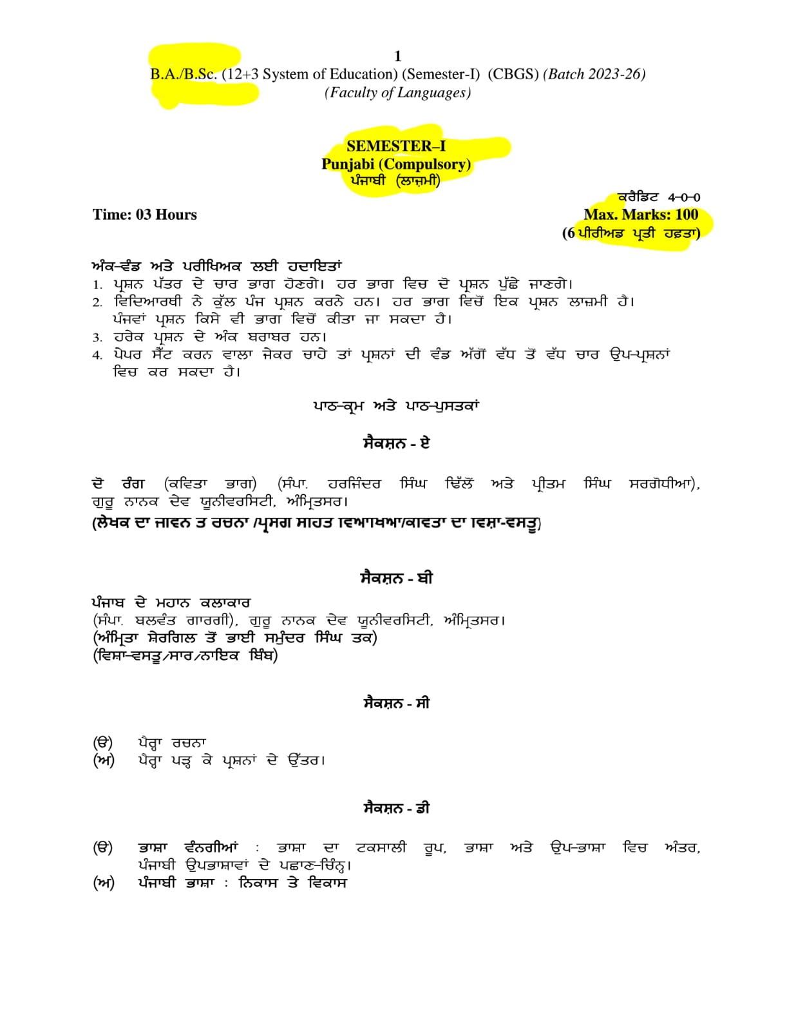

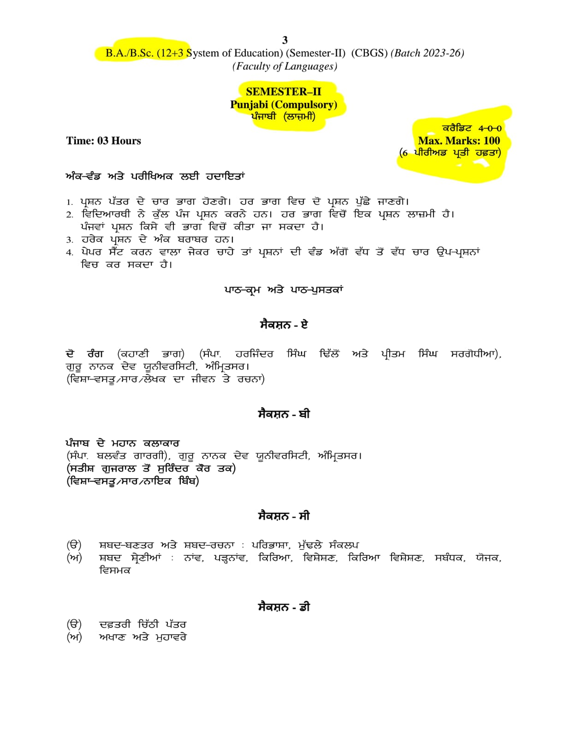

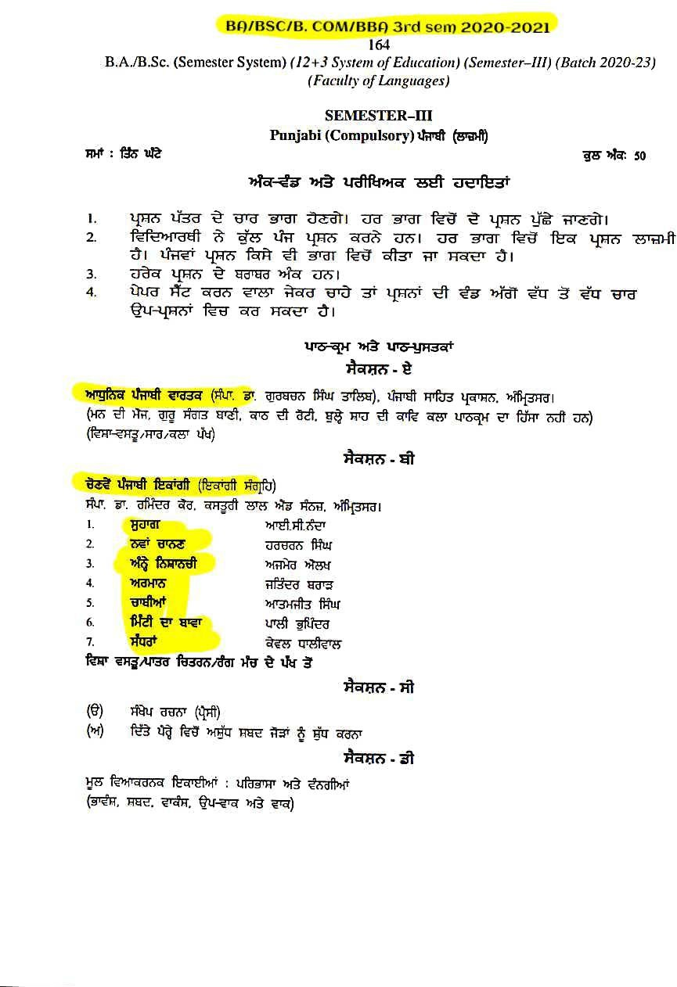

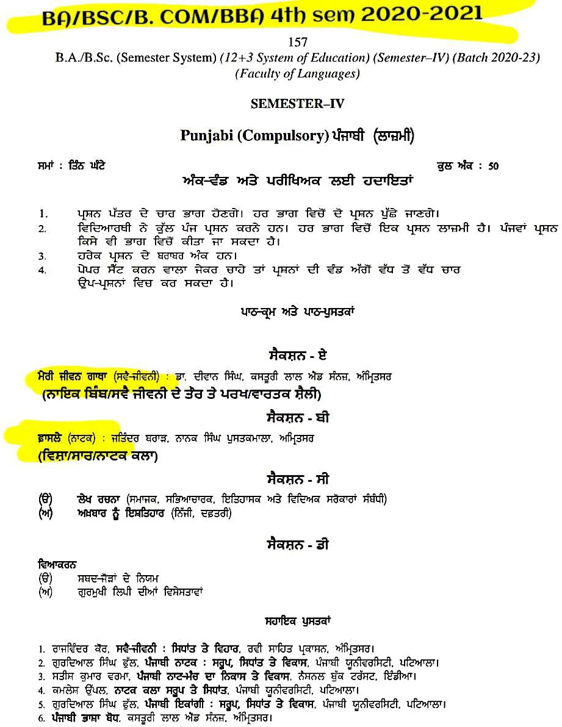

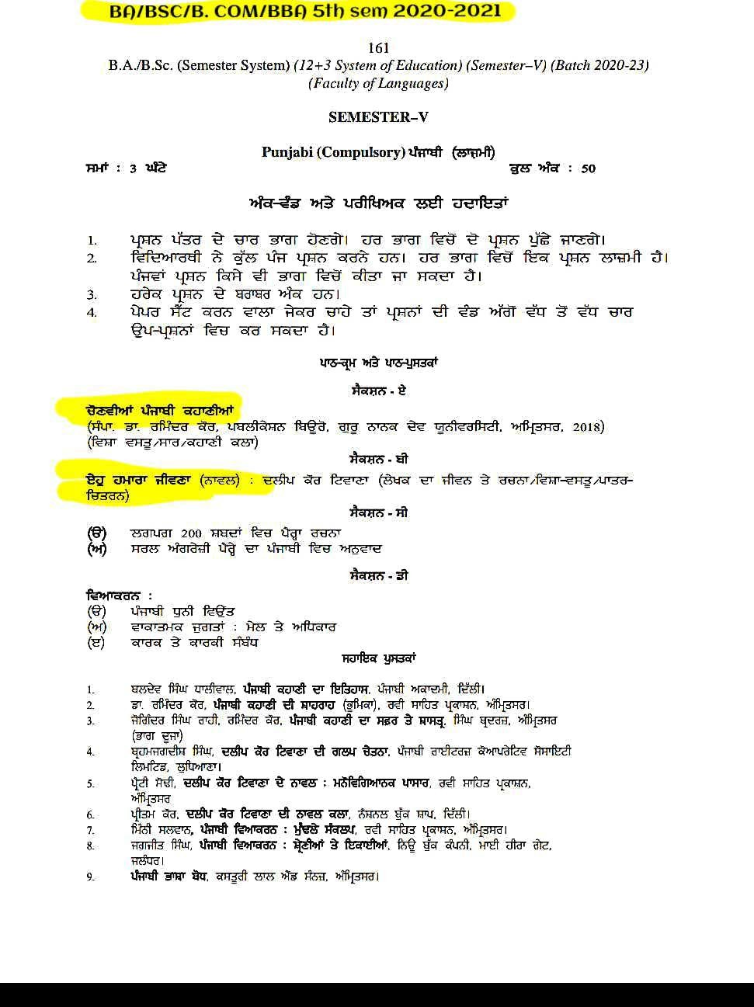

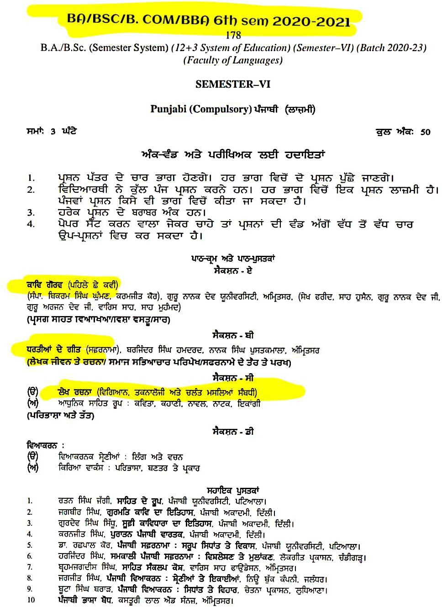

El. Punjabi

SESSION | CLASS/SUBJECT | GENDER
2022-23 | BA SEM 1STELECTIVEPUNJA BI | - KAAV RANG (POETRY)Dropadi,DharmaBabla,Nadiye Nit Era NeerDolda,MavaThandiaChava,Lori  ,HarnakshNahiMarya  - Novel: SOORJADEHAANI
2022-23 | BA SEM 2NDELECTIVEPUNJ ABI | - SANSAARDIYAPARSIDHKAHANIA ( STORIES)
2022-23 | BA SEM 2NDELECTIVEPUNJ ABI | PostMaster,MeriGulbadan  ,EkSerKanak, Udaasi, DhartiHethlaBold,DarveshaDaTohfa, Gaato, Ma Da Dil,TobaTekSingh,KhaliDhol,Kathakaar,DeshWapsi
2022-23 | BA SEM 3rd ELECTIVEPUNJABI | - HeerWaris,PooranBhagat,NadirShahDiVaar  - KAHANIYA:-  bhaboimaina,raasleela,buttshikan,murkiyan,uhsochdi,she hzaad
2022-23 | BA SEM 4th ELECTIVEPUNJABI | - PunjabiLokKaavTeSbhyachar,PutliyanDaTmasha, Bhanda Di BhandiTeMediyeDiMaar,PunjabiFilmanDiSbhyacharkParkh  .
2022-23 | BA SEM 5thELECTIVEPUNJA BI | - HEER VARIS SHAH  - Chandidivaar  - Natak :chandan deohle  - Nibandh:ma,maboli,vasejitheazadiohdeshmera
2022-23 | BA SEM 6THELECTIVEPUNJA BI | SriGuruNanakKaalDaSaahit, NaathBhagatBaani DaItihaas, QissaKaavDa Visha.

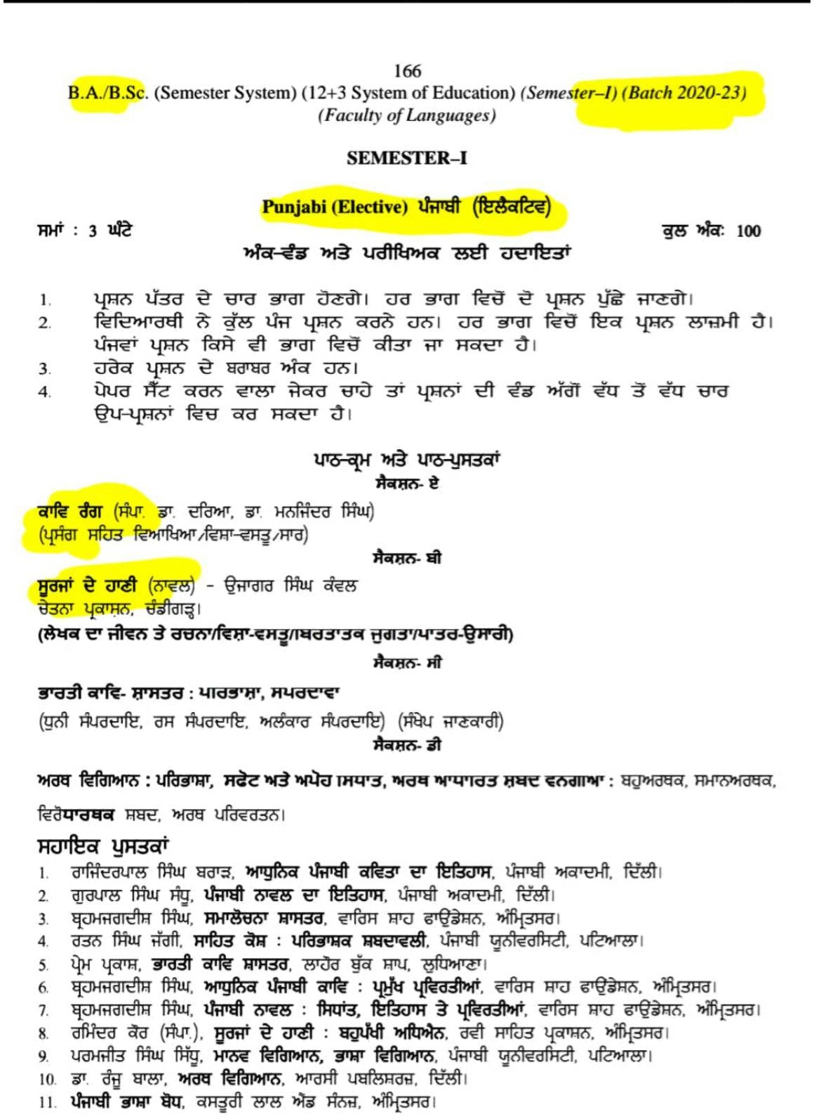

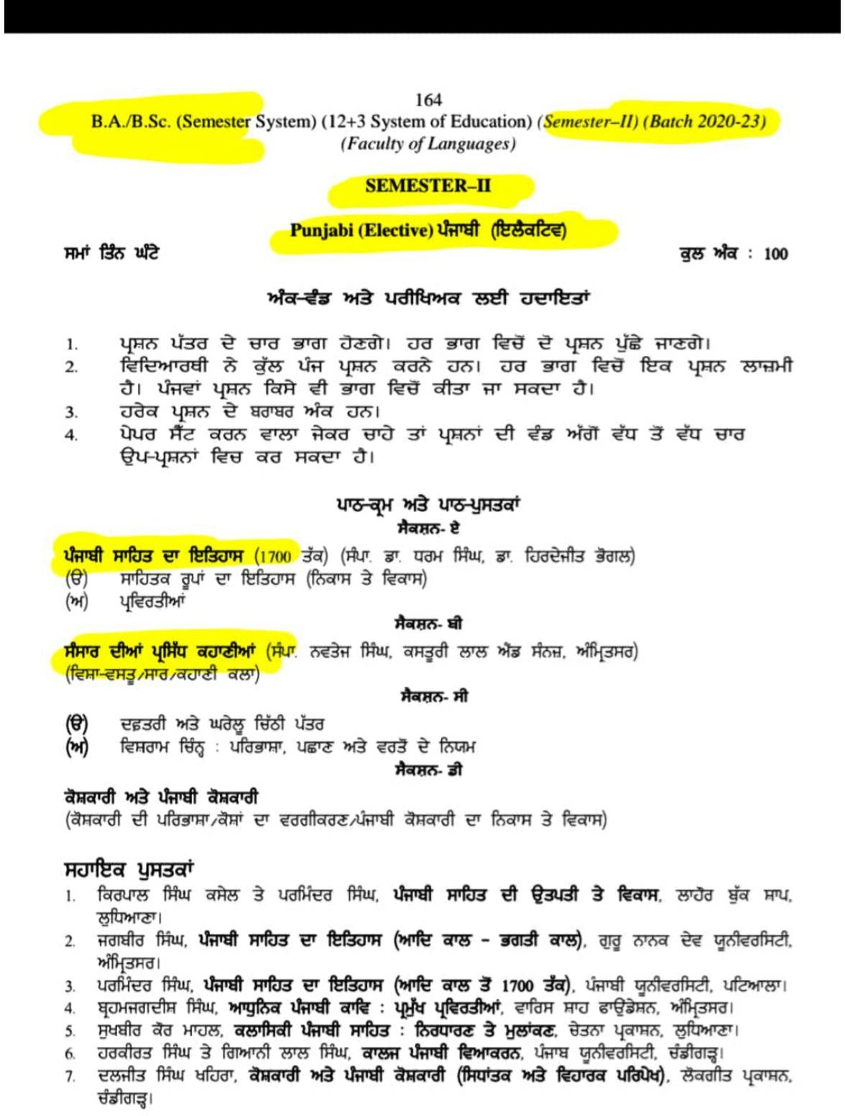

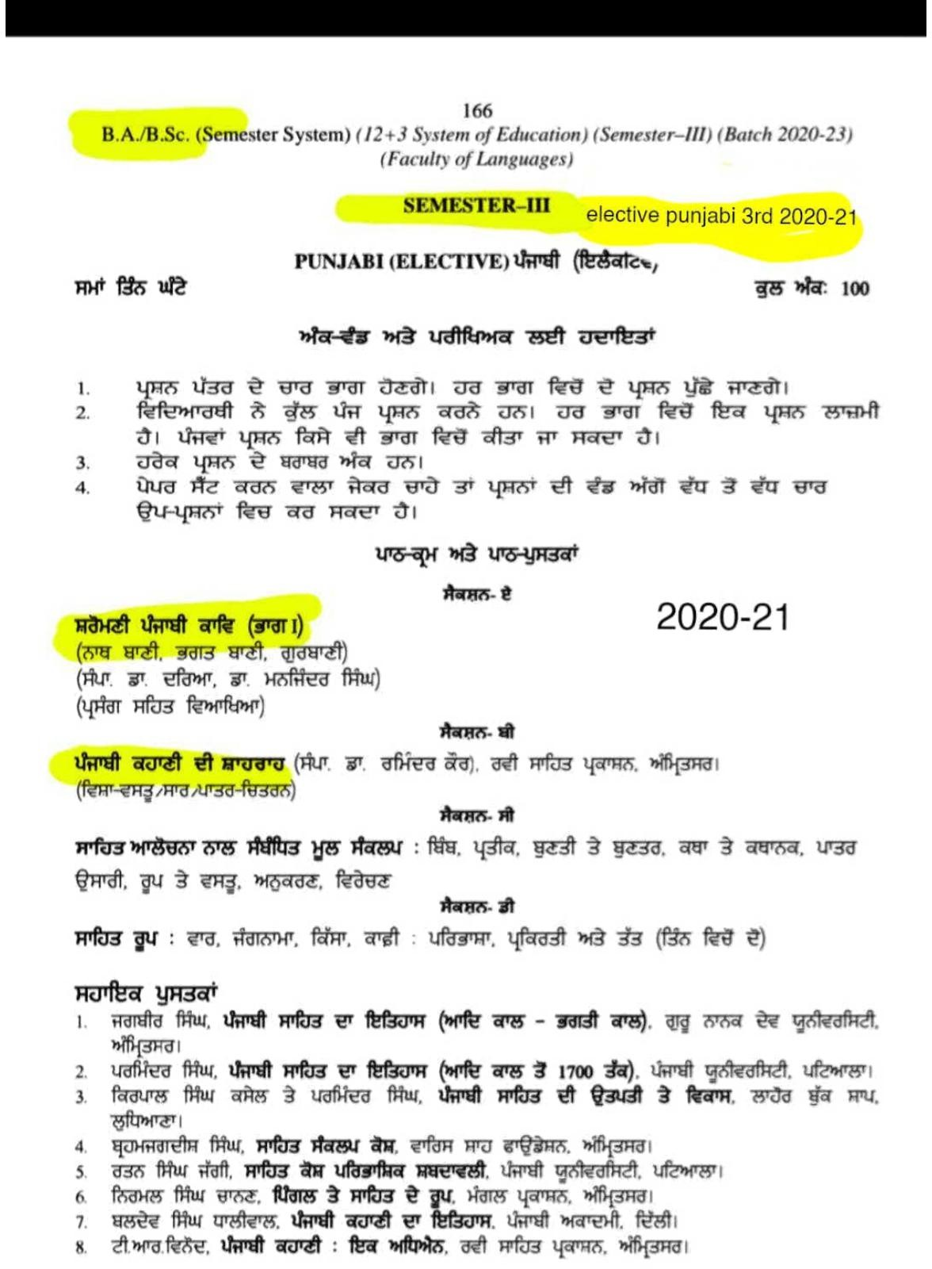

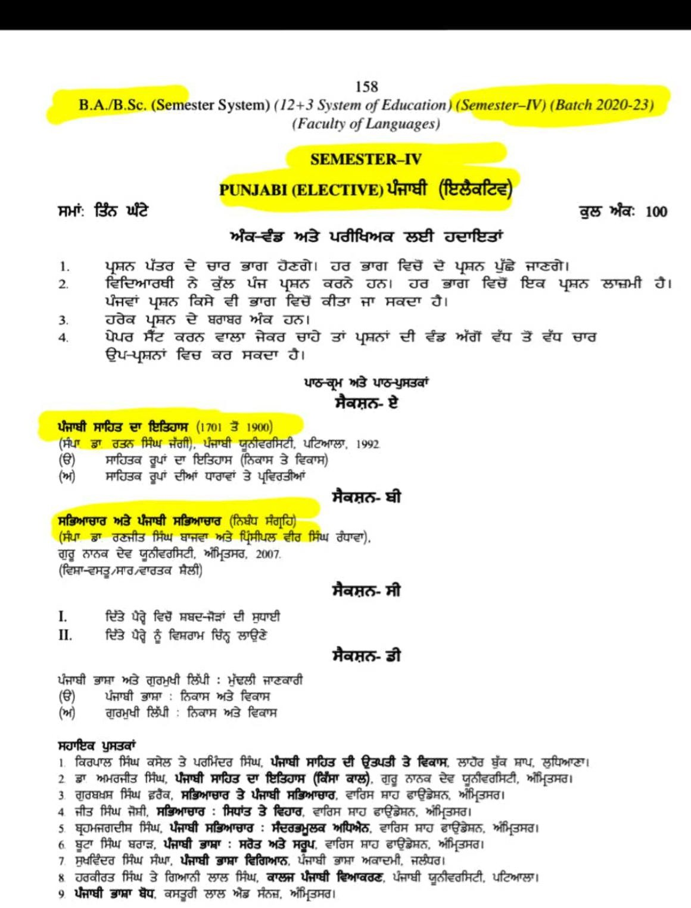

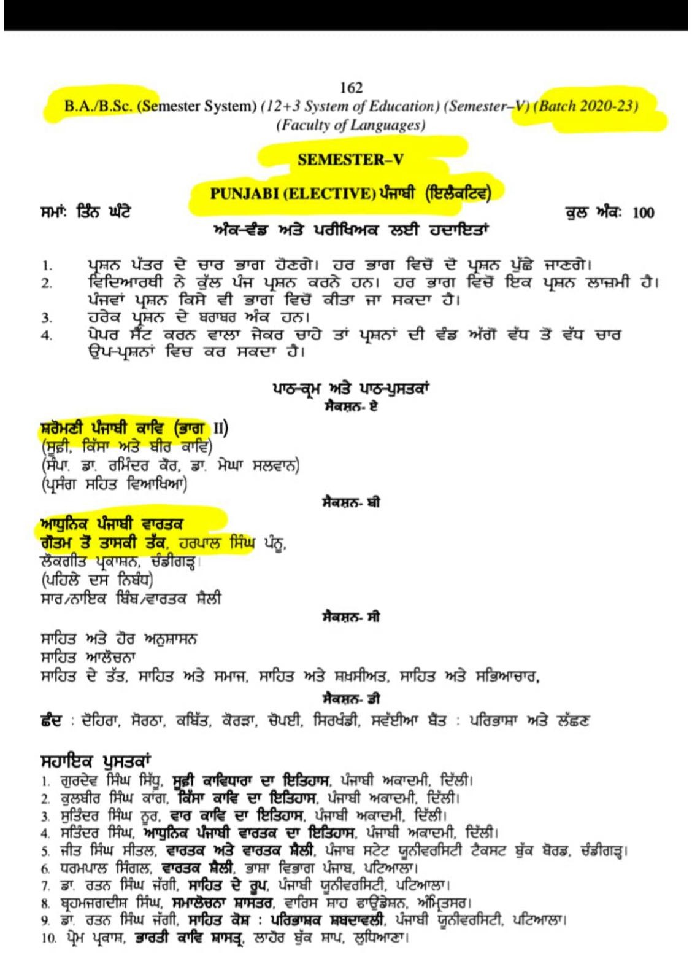

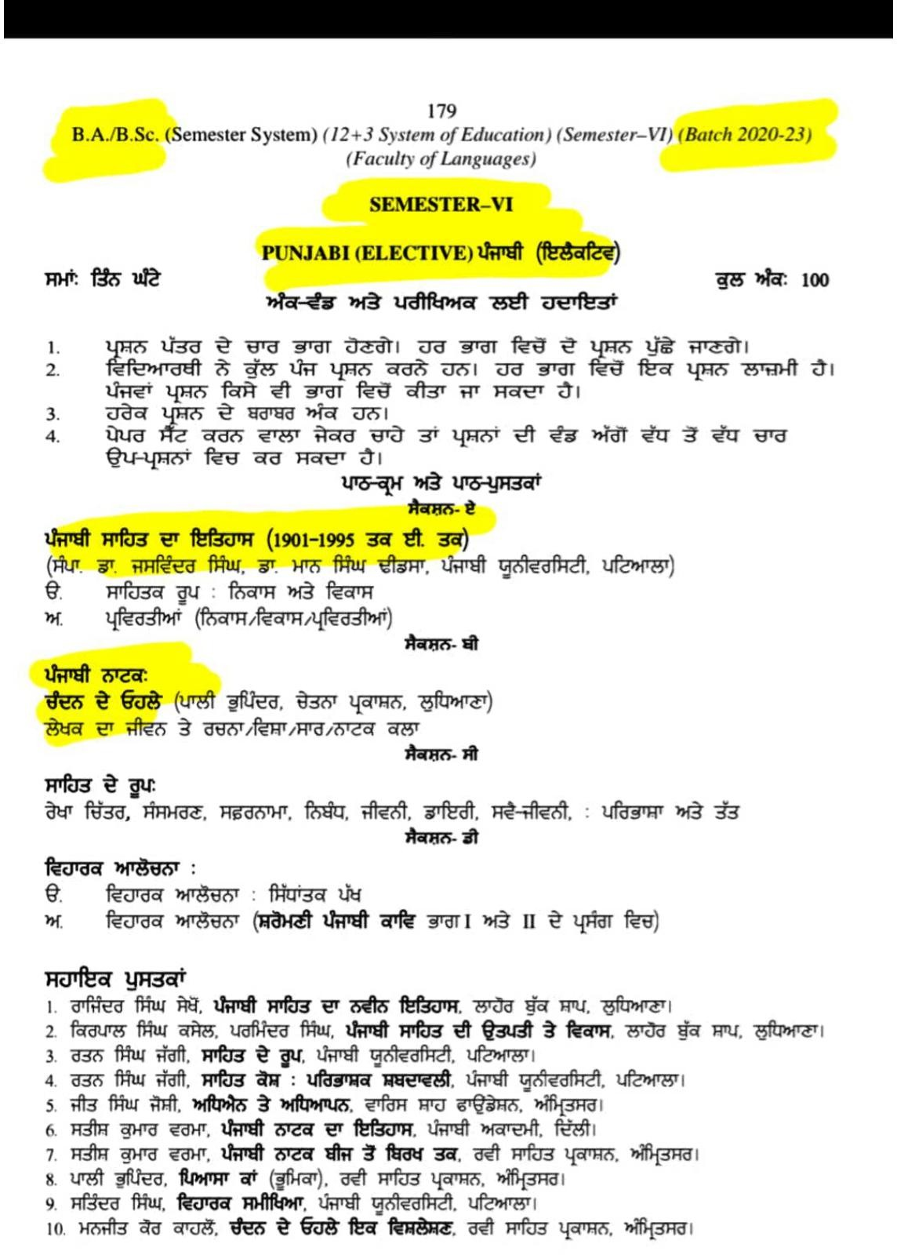

ENGLISH (COMPULSORY)

(B.A/B.Sc/B.Com-I)
- „The Shroud‟ by Munshi Prem Chand (Tales of Life)
- „The Power of Women‟ by Richard Gordon (Prose for Young Learners)

B. A./B.Sc. (Semester System) (12+3 System of Education) (Semester–I)
C. (Faculty of Languages)

SEMESTER–I ENGLISH (COMPULSORY)
Time: 3 Hours Max. Marks: 50
Instructions for the Paper Setters:-
Eight questions of equal marks (Specified in the syllabus) are to be set, two in each of the four Sections (A-D). Questions may be subdivided into parts (not exceeding four). Candidates are required to attempt five questions, selecting at least one question from each Section. The fifth question may be attempted from any Section.
Texts Prescribed:-
- Tales of Life (Guru Nanak Dev University, Amritsar) Stories at Sr.No.1, 2, 3, 5 and 6
- Prose for Young Learners (Guru Nanak Dev University, Amritsar) Essays at Sr. No. 1, 2, 3, 5 and 6
- English Grammar in Use (Fourth Edition) by Raymond Murphy, CUP The syllabus is divided in four sections as mentioned below. SECTION–A
English Grammar in Use, 4th Edition by Raymond Murphy, CUP (Units: 1-37)

SECTION–B
Paragraph Writing and English Grammar in Use (Units: 38-48)

SECTION–C
Tales of Life(Guru Nanak Dev University, Amritsar): Stories at Sr. No. 1, 2, 3, 5 and 6

SECTION–D
Prose for Young Learners: Essays at Sr. No. 1, 2, 3, 5 and 6

(B.A/B.Sc/B.Com-Sem II)
1. „Eveline‟ (Tales of Life)

B. A./B.Sc. (Semester System) (12+3 System of Education) (Semester–II)
C. (Faculty of Languages)

SEMESTER–II ENGLISH (COMPULSORY)
Time: 3 Hours Max. Marks: 50
Instructions for the Paper Setters:-
Eight questions of equal marks (Specified in the syllabus) are to be set, two in each of the four Sections (A-D). Questions may be subdivided into parts (not exceeding four). Candidates are required to attempt five questions, selecting at least one question from each Section. The fifth question may be attempted from any Section.
Texts Prescribed:
- Tales of Life (Guru Nanak Dev University, Amritsar) Stories at Sr. No. 7, 9, 10, 11, 12
- Prose for Young Learners (Guru Nanak Dev University, Amritsar) Essays at Sr. No. 7, 8, 9, 10, 11
- English Grammar in Use (Fourth Edition) by Raymond Murphy, CUP (Units: 49-97)
The syllabus is divided in four sections as mentioned below. SECTION–A
English Grammar in Use, 4th Edition by Raymond Murphy, CUP (Units: 49-81)

SECTION–B
Personal letter Writing and English Grammar in Use (Units: 82-97)

SECTION–C
Tales of Life (Guru Nanak Dev University, Amritsar) 7, 9, 10, 11, 12

SECTION–D
Prose for Young Learners(Fourth Edition) by Raymond Murphy, CUP 7, 8, 9, 10 and 11

(B.A/B.Sc/B.Com-III)
- „Belinda‟s Dressing Table‟ by A. Pope (Moments in Time)
- „Porphyria‟s Lover‟ by Robert Browning (Moments in Time)

B.A./B.Sc. (Semester System) (12+3 System of Education) (Semester–III) (Faculty of Languages)

SEMESTER–III ENGLISH (COMPULSORY)
Time: 3 Hours Max. Marks: 50
Instructions for the Paper Setters:-
Eight questions of equal marks (Specified in the syllabus) are to be set, two in each of the four Sections (A-D). Questions may be subdivided into parts (not exceeding four). Candidates are required to attempt five questions, selecting at least one question from each Section. The fifth question may be attempted from any Section.
Important Note: The textbook Making Connections (3rd edition) is significantly different from its 2nd edition. The third edition (by Kenneth J Pakenham, Jo EcEntire, Jessica Williams) is to be followed for this course.
Texts Prescribed:
- Making Connections by Kenneth J. Pakenham, Jo McEntire, Jessica Williams, 3rd Edition. CUP.
- Moments in Time: An Anthology of Poems, GNDU, Amritsar.
- English Grammar in Use (Fourth Edition) by Raymond Murphy, CUP
Syllabus is divided into four sections as mentioned below:

SECTION–A
English Grammar in Use (Fourth Edition) by Raymond Murphy, CUP: Units 98-130

SECTION–B
Essay writing and English Grammar in Use: Units 131-145

SECTION–C
Moments in Time: Poems at Sr. No. 1-6

SECTION–D
Making Connections by Kenneth J. Pakenham, 3rd Edn. CUP: Unit-I (Global Health) and Unit-II (Multicultural Societies)

(B.A/B.Sc/B.Com-IV)
BA./B.Sc. (Semester System) (12+3 System of Education) (Semester–IV) (Faculty of Languages)

SEMESTER–IV ENGLISH (COMPULSORY)
Time: 3 Hours Max. Marks: 50
Instructions for the Paper Setters:-
Eight questions of equal marks (Specified in the syllabus) are to be set, two in each of the four Sections (A-D). Questions may be subdivided into parts (not exceeding four). Candidates are required to attempt five questions, selecting at least one question from each Section. The fifth question may be attempted from any Section.
Important Note: The textbook Making Connections (3rd edition) is significantly different from its 2nd edition. The third edition (by Kenneth J Pakenham, Jo EcEntire, Jessica Williams) is to be followed for this course.
Texts Prescribed:-
- Making Connections by Kenneth J. Pakenham, Jo McEntire, Jessica Williams, 3rd Edition. CUP.
- Moments in Time: An Anthology of Poems, GNDU, Amritsar.
- English Grammar in Use (Fourth Edition) by Raymond Murphy, CUP.
Syllabus is divided into four sections as mentioned below:

SECTION–A
English Grammar in Use (Fourth Edition) by Raymond Murphy, CUP: Revision of Units 26-37, 42-48, 92- 97, 113-120.

SECTION–B
Moments in Time: Poems at Sr. No. 7-12

SECTION–C
Making Connections by Kenneth J. Pakenham, 3rd Edn. CUP: SECTION–III (Aspects of Language) and SECTION–IV (Sustaining Planet Earth)

SECTION–D
Essay type question based on the SECTION–“Beyond the reading” from the text, Making Connections.

(B.A/B.Sc/B.Com-V)
- „The Portrait‟ by Robert Graves
- „Mirror‟ by Sylvia Plath
B.A./B.Sc./B.Com (Semester System) (12+3 System of Education) (Semester–V)
SEMESTER–V ENGLISH COMPULSORY
Time: 3 Hours Max. Marks: 50
Instructions for the Paper Setters:-
Eight questions of equal marks (Specified in the syllabus) are to be set, two in each of the four Sections (A-D). Questions may be subdivided into parts (not exceeding four). Candidates are required to attempt five questions, selecting at least one question from each Section. The fifth question may be attempted from any Section.
Texts Prescribed:
- All My Sons by Arthur Miller
- Poems of Nature and Culture, Guru Nanak Dev University, Amritsar
Poems of Nature and Culture
William Wordsworth: “The World is Too Much with Us” Gordon Lord Byron: “She Walks in Beauty”
P.B. Shelly: “Ozymandias”, Alfred Lord Tennyson: “In Memoriam” Robert Browning: “Meeting at Night”,Mathew Arnold: “Dover Beach”
W.B. Yeats: “Words”
Wilfred Owen: “Strange Meeting” Robert Graves: “The Portrait”
W.H. Auden: “The Unknown Citizen”
Dylan Thomas: “Do not Go Gentle into That Good Night” Ted Hughes: “The Thought-Fox”
Sylvia Plath: “Mirror” Seamus Heaney: “Honeymoon Flight”
Rabindranath Tagore: “False Religion” Nissim Ezekiel: “Night of Scorpion”
- Formal letter and application writing, Resume Writing, Business Writing and Report writing
The syllabus is divided into four sections as mentioned below:
Section A- All My Sons by Arthur Miller the whole text.
Section B- Poems of Nature and Culture Guru Nanak University, Amritsar. Section C- Formal Letter and Application Writing.
Section D- Business Writing and Report Writing, Resume Writing
Instructions for the paper-setter and distribution of marks:
The question paper will consist of four sections and distribution of marks will be as under: The question paper will be divided into four sections:
SECTION–A
Section A will consist of two questions. Question one will consist of three short answer questions and the students are required to attempt any two. Each question will carry 4 marks. (2X4=8). Total weightage of this section is 15 marks.
Question two, an essay type question with internal choice will be set. It will carry 7 marks. (1X7=7)
SECTION–B
Three short answer type questions based on the central idea, theme, tone or style etc. of the prescribed poems will be set. The students are required to attempt any two. Each question carries three marks. (2x3=6) One question with internal choice requiring the students to explain a stanza with reference to the context will be set. (1x4=4) It carries four marks. One essay- type question with internal choice from the poems prescribed will be set. It carries five marks. (1x5=5). Total weighage of this section is 15 marks.
SECTION–C
Two questions will be set in this section. One question will be set on Formal Letter Writing. It carries five marks. Another question on Application Writing will be set. It also carries five marks. (5+5=10)
SECTION–D
Two questions will be set in this section. One question will be on Resume Writing/ Business
Writing. It carries five marks. Another question based on ReportWriting will be set. It carries five marks. (5+5=10)

B.A./B.Sc. (Semester System) (12+3 System of Education) (Semester–VI) (Faculty of Languages)

SEMESTER–VI ENGLISH (COMPULSORY)
Time: 3 Hours Max. Marks: 50
Instructions for the Paper Setters:-
Eight questions of equal marks (Specified in the syllabus) are to be set, two in each of the four Sections (A-D). Questions may be subdivided into parts (not exceeding four). Candidates are required to attempt five questions, selecting at least one question from each Section. The fifth question may be attempted from any Section.
Texts Prescribed:
- The Guide by R.K. Narayan
- Glimpses of Theatre, Guru Nanak Dev University Amritsar.
  - “The Will”
  - “Villa for Sale”
  - “Progress”
  - “The Monkey‟s Paw”
- “Sorry Wrong Number”
- “No eggs!No eggs!”
SECTION–A
Study of the novel, The Guide by R.K. Narayan.
SECTION–B
One- act plays, and “The Will” and “Villa for Sale” fromGlimpses of Theatre,Guru Nanak Dev University Amritsar.
SECTION–C
One- act plays, “Progress” and “The Monkey’s Paw” from Glimpses of Theatre, Guru Nanak Dev University Amritsar and Essay writing.
SECTION–D
One-act plays, “Sorry Wrong Number” and “No eggs! No eggs!” from Glimpses of Theatre,
Guru Nanak Dev University Amritsar.
Instructions for the paper-setter and distribution of marks:
The question paper will consist of four sections and distribution of marks will be as under:
The question will be divided into four sections:
SECTION–A
Four short answer type questions based on Section 1 will be set. The students are required to attempt any three. Each question carries four marks. One essay type question with internal choice will be set. It carries 8 marks. (3X4+8=20 marks) SECTION–B
Three very short answer type questions will be set on character, tone, plot and themes of One- act plays. The students are required to attempt any two. (2x2=4) Each question carries two marks. (1x6=6) One essay type question with internal choice will be set. It carries six marks. The total weightage of this section is 10 marks.
SECTION–C
Three short answer type questions will be set on character, tone, plot and themes of One- act plays. The students are required to attempt any two. (2x2=4) Each question carries two marks. One essay type question with internal choice will be set. It carries six marks. (1x6=6). The total weightage of section is 10 marks.
SECTION–D
Three short answer type questions will be set on character, tone, plot and themes of One- act plays. The students are required to attempt any two. (2x2=4) Each question carries two marks. One essay type question with internal choice will be set. It carries six marks. (1x6=6). The total weightage of this section is 10 marks.

B.A. (HONOURS) 12+3 SYSTEM OF EDUCATION SEMESTER–V
ENGLISH ENGLISH NOVEL
Time: 3 Hours Max. Marks: 100
Instructions for the paper setter and distribution of marks:
Nine essay type questions (three questions on each novel) will be set. The examinees will be required to answer any five choosing at least one question on each novel. Each question will carry20 marks.
Course Contents:
- The Mayor of Caster Bridge by Thomas Hardy
- A Farewell to Arms by Ernest Hemmingway
- The Shadow lines by AmitavGhosh

(M.A-I)
  - Pride and Prejudice by Jane Austen (Paper-III)
  - Jude, the Obscure by Thomas Hardy (Paper-III)
  - Sons and Lovers by D.H. Lawrence (Paper-VIII)

(M.A-II)
  - Fasting, Feasting by Anita Desai (Paper-XIV)
  - Poetry of Kamala Das
  - The Scarlet Letter by Nathaniel Hawthorne

M.A. ENGLISH
(Syllabus for the Batch from Year 2020 to Year 2022) SEMESTER–I

PAPER–III: ENGLISH NOVEL (UPTO 19TH CENTURY)
Time: 3 Hours Max. Marks: 80
Instructions for the Paper Setters:-
Eight questions of equal marks (Specified in the syllabus) are to be set, two in each of the four Sections (A-D). Questions may be subdivided into parts (not exceeding four). Candidates are required to attempt five questions, selecting at least one question from each Section. The fifth question may be attempted from any Section.
SECTION–A
Henry Fielding: Joseph Andrews SECTION–B
Jane Austen: Pride and Prejudice SECTION–C
Charles Dickens: Hard Times SECTION–D
Thomas Hardy: Jude the Obscure
Suggested Reading:-
- Walton Litz. Jane Austen: A Study of Her Artistic Development. London: Chatto& Windus, 1965.
- Allan Grant. A Preface to Dickens. London: New York, 1984.
- Judith O‟Neill, Ed. Critics on Jane Austen. Florida: University of Miami Press, 1977.
- B.C. Southam. Critical Essays on Jane Austen. London: Routledge, 1968.
- David Lodge, Ed. Emma: A Casebook. London: Macmillan. 1968
- Draper, R. P., Ed. Hardy: The Tragic Novels (A Casebook). London: Macmillan, 1975.
- Elizabeth Jenkins. Henry Fielding. London: Arthur Barker, 1966.
- Glenn W. Hatfield. Henry Fielding and the Language of Irony. Chicago & London: The University of Chicago Press, 1968.
- Guerard, Albert J., Ed. Hardy: A Collection of Critical Essays. New Jersey: Prentice-Hall, 1963.
- Harold Bloom, Ed. Jane Austen's Emma: Modern critical interpretations. New York: Chelsea House, 2010.
- K.J. Fielding. Charles Dickens: A Critical Introduction. London: Longmans, 1965
- Lionel Trilling. “Emma and the Legend of Jane Austen.” Beyond Culture: Essays on Literature and Learning. New York: Viking Press, 1965.
- Michael and Mollie Hardwick. The Charles Dickens Companion. London

M.A. ENGLISH
(Syllabus for the Batch from Year 2020 to Year 2022) SEMESTER–II

PAPER–VIII: MODERN NOVEL
Time: 3 Hours Max. Marks: 80
Instructions for the Paper Setters:-
Eight questions of equal marks (Specified in the syllabus) are to be set, two in each of the four Sections (A-D). Questions may be subdivided into parts (not exceeding four). Candidates are required to attempt five questions, selecting at least one question from each Section. The fifth question may be attempted from any Section.
SECTION–A
D.H. Lawrence: Sons and Lovers SECTION–B
Virginia Woolf: Mrs Dalloway SECTION–C
Joseph Conrad: Heart of Darkness SECTION–D
William Golding: Lord of the Flies Suggested Reading:-
- Bose, Bindra, ed. Heart of Darkness. New Delhi: Oxford University Press, 2001.
- Curle, Richard. Joseph Conrad and His Characters: A Study of Six Novels. London: Heinemann, 1968.
- Anne Fernihough. The Cambridge Companion to D.H. Lawrence. Cambridge University Press, 2001.
- Keith Sagar. D.H. Lawrence: Life into Art. New York: Penguin, 1986.
- Gamini Salgado, ed. Sons and Lovers: A Casebook. London: MacMillan, 1969.
- Linda Ruth Williams. D. H. Lawrence (Writers and their Work). New Delhi: Atlantic, 2010.
- Harold Bloom, Virginia Woolf‟s Mrs. Dalloway (Bloom‟s Modern Critical Interpretations), London: Chelsea House Publications, 1988.
- Dowling, David. Mrs Dalloway: Mapping Streams of Consciousness. New York: Twayne Publishers, 1991.
- Bose, Brinda, Ed. Mrs Dalloway: Worldview Critical Editions. New Delhi: Worldview Publications, 2001.
- Chakoo, B. L., ed. William

M.A. ENGLISH (SEMESTER–III)
PAPER–XIV: INDIAN WRITING IN ENGLISH
Time: 3 Hours Max. Marks: 80
The question paper shall consist of Parts-A and B having 24 and 56 marks respectively.
Part-A: Eight (8) short questions (two from each unit) will be set. Students will be required to answer six (6) of them. The short questions are aimed at examining the first hand reading of prescribed texts. These shall relate to particular themes, actions, characters, setting, literary / linguistic significance of selected scenes / stanzas etc. The narrower the question, the better it is. The students shall answer these questions within 150 words each. Each question will carry
4 marks.(4x6=24)
Part-B: Four (4) questions (one from each Unit) will be set. The students will be required to attempt all. Each question will have internal choice. One of the two choices should preferably deal with literary and social background of the author / text. If required, the examiner may also have sub-parts of a question. The students shall answer these questions in not more than 800 words. Each question will carry 14 marks. (14x4=56)

UNIT–I
Nissim Ezekiel:
“Enterprise” “Philosophy”
“Night of the Scorpion” “Poet, Lover, Birdwatcher” “The Visitor” “Background, Casually”
“Goodbye Party for Miss Pushpa, T.S”
Kamala Das:
“An Introduction” “The Freaks”
“My Grandmother's House” “A Hot Noon in Malabar” “The Sunshine Cat”
“The Invitation”

UNIT–II
R.K. Narayan: The Guide

UNIT–III
Anita Desai: Fasting, Feasting

UNIT–IV
Arundhati Roy: The God of Small Things

M.A. ENGLISH (SEMESTER–IV) PAPER–XVII: AMERICAN LITERATURE
Time: 3 Hours Max. Marks: 80
The question paper shall consist of Parts-A and B having 24 and 56 marks respectively.
Part–A: Eight (8) short questions (two from each unit) will be set. Students will be required to answer six (6) of them. The short questions are aimed at examining the first hand reading of prescribed texts. These shall relate to particular themes, actions, characters, setting, literary / linguistic significance of selected scenes / stanzas etc. The narrower the question, the better it is. The students shall answer these questions within 150 words each. Each question will carry
4 marks.(4x6=24)
Part–B: Four (4) questions (one from each Unit) will be set. The students will be required to attempt all. Each question will have internal choice. One of the two choices should preferably deal with literary and social background of the author / text. If required, the examiner may also have sub-parts of a question. The students shall answer these questions in not more than 800 words. Each question will carry 14 marks. (14x4=56)

UNIT–I
Walt Whitman
From “Song of Myself” Sec. 1, 6, 32, 40 “Crossing Brooklyn Ferry”
“Out of the Cradle Endlessly Rocking”
Robert Frost
“Stopping by the Woods on a Snowy Evening” “The Road not Taken”
“Mending Wall” “After Apple Picking” “Birches”
“Neither Out Far Nor In Deep” “The Onset”
“Design”
“The Gift Outright”

UNIT–II
Nathaniel Hawthorne: The Scarlet Letter

UNIT–III
Arthur Miller: Death of a Salesman

UNIT–IV
Saul Bellow: The Victim

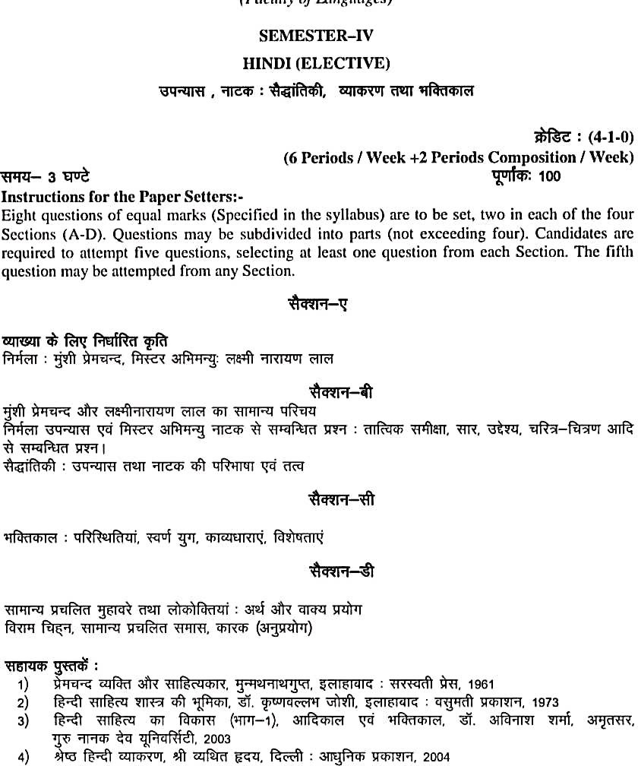

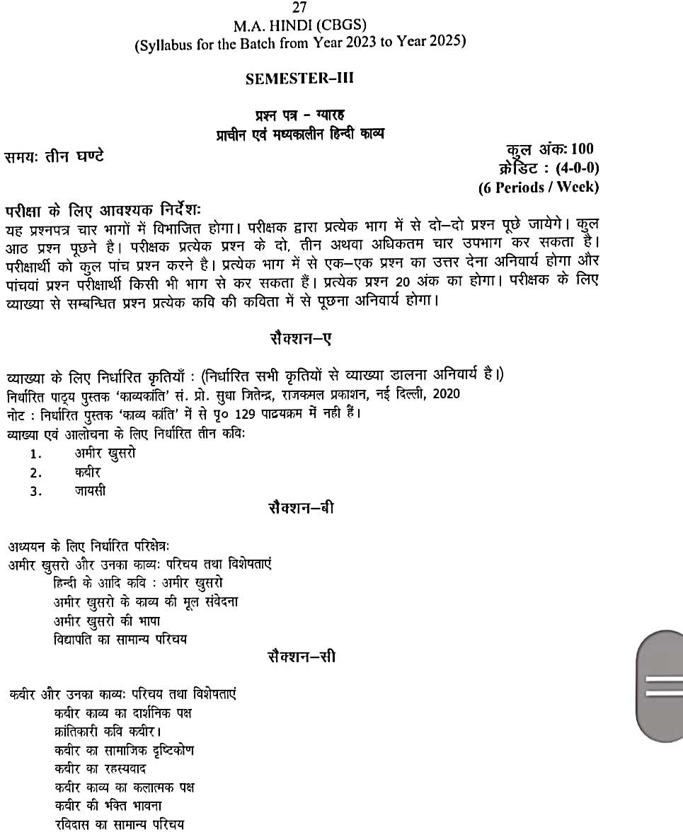

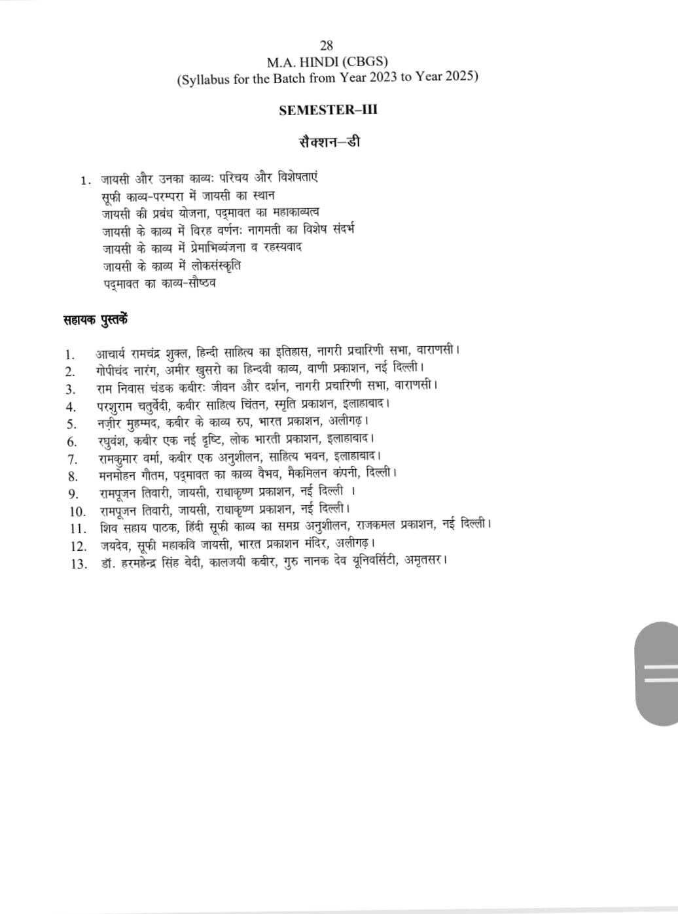

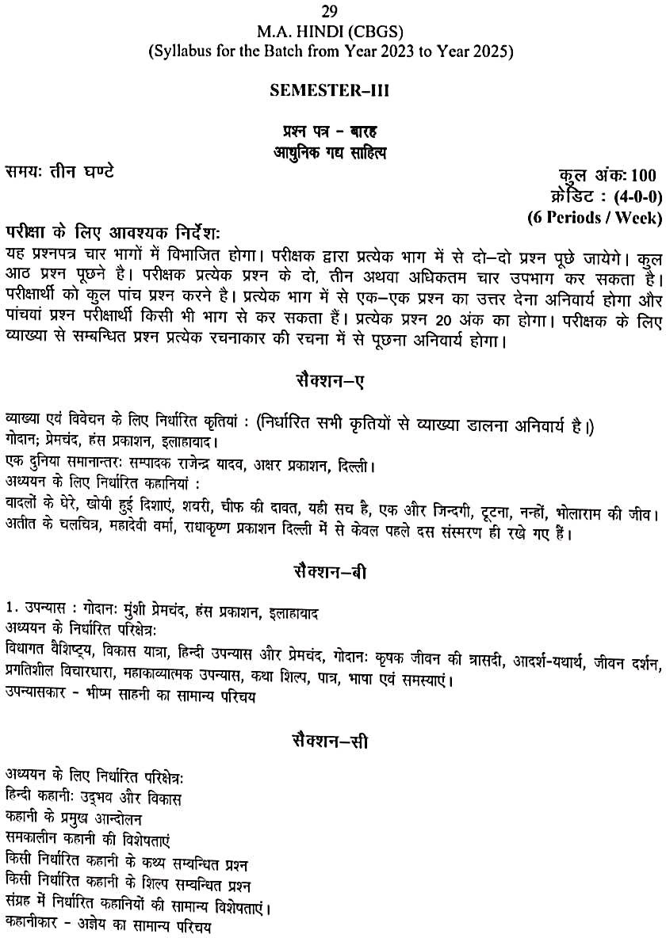

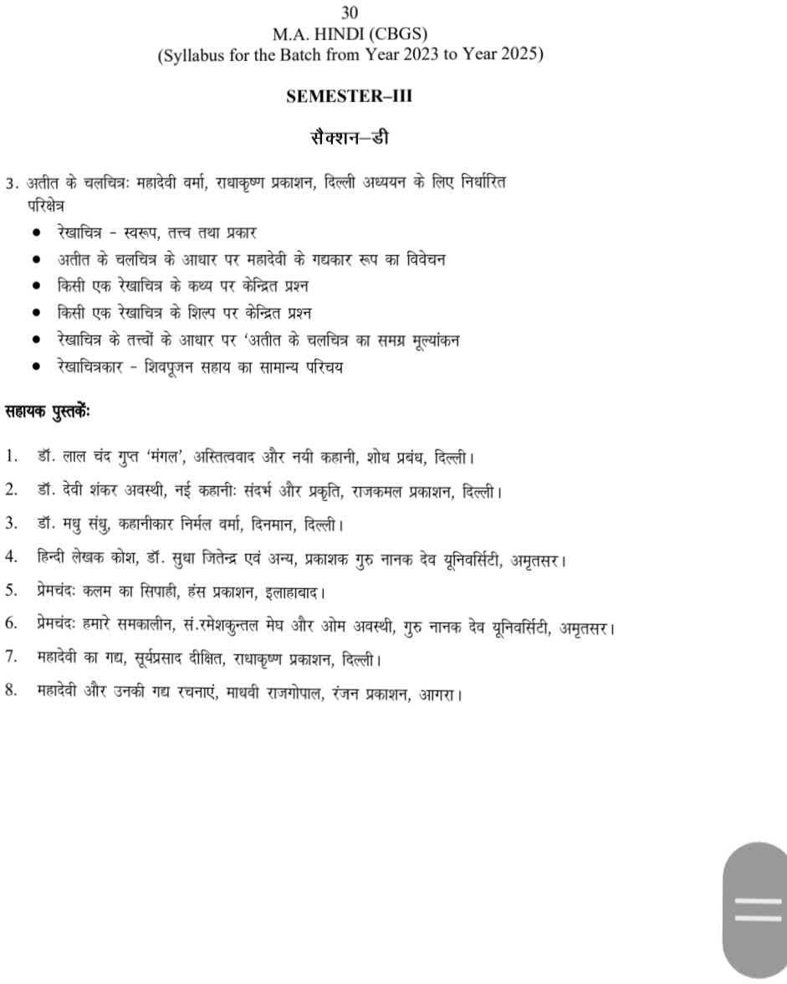

Bachelor of Vocation (B.Voc.) (Fashion Technology) (Semester-I)
(GENDER)

Paper-VI:PatternMaking&Construction-
I(Practical)

Time:3Hrs Marks:50
Instructions to the Examiners/Paper Setters: Question paper will be set on the spot. Course Contents
Basics of pattern making
What is pattern making, basic points on body, how to take measurements, basic bodice and basic sleeve of kids (2 yrs.)
Infant’s garment pattern making, layout and cutting and stitching of
- Bloomer
- Romper
Pattern making, layout, cutting and stitching of
- boy‟sbushirt
- boy‟sshorts

Casual wear Night wear Party wear
- to make patterns of a casual dress for girl aged 2 to 3 years( one)
- to make patterns of a night dress for boy aged 5 to 6years(one)
- to make patterns of a party wear dress for girl aged 7 to 8 yearsand stitch it.(one)

(GENDER)

B.VOC. FASHION TECHNOLOGY SEM.II

Paper-V:
FashionIllustration&DesignDeve lopment(Practical)
Time:3Hrs Marks:50
Instructions to the Examiners/Paper Setters: Question paper will be set on the spot.
Course Content:

SECTION A: ILLUSTRATION KIDS
  - Kids croquie boy and girl(Age group – infant, toddler, 2 years,5 yearsand 8years)
  - Makeposes
  - Face, arms, legs, hands, hair style, features,feet.

SECTION B: BABY TEXTURES AND RENDERING

    - Bring fabrics from market and learn to renderthem
    - Create your own babytextures.

SECTION C: DESIGNING OF KIDS WEAR

- Dress rendering on croquie (oneeach)
  - Casual Wear – age 2 to 3 years (boy andGirl) o Night Suit – age 5 to 6 years (boy andGirl) o Party Wear – age 7 to 8 years (boy andGirl)
- Use of various design details and learn how to sketch oncroquie.
Reference Book
- 9 heads by KathrynHagen
- Patrick john Ireland
- Allen seaman- fashiondrawing
- Fashion illustration and Rendering by BinaAbling.

B.VOC FASHION TECHNOLOGY SEM. II (GENDER)
Paper- VI: PORTFOLIO DEVELOPMENT (kids)
(Practical)
Time:3Hrs Marks:50
Instructions to the Examiners/Paper Setters: Question paper will be set on the spot.
Course Contents
Instructions to the Internal Faculty: The art portfolio is an expression of a student‟s creativity, design/ ability, technical expertise, illustration and presentation skills. It should exhibit the student‟s inclination towards the particular segment of the industry by identifyingthetargetcustomers,designrequirementsandpricing.Itshouldideallycomprise of 30-35 sheets keeping the following points inmind.
Uniform Format: It is important to keep all the sheets of the same size to maintain visual continuity. Sheets should be grouped separately and systematically either horizontally or vertically.Thisensuresuniformityofpresentation.Thepresentationoftheportfoliodepends on the contents and also on layouts. The end result should look very neat andprofessional.

The Portfolio must include:
Design Development
- CurriculumVita
- Page ofContents
- Theme of theproject
- Mood board, Story Board, Ideation Board, Colour Palette and Fabric Chart.Research
- Finalization ofTheme
- Sourcing
- Finalization ofdesigns
- Measurements and specificationsheets
- Thumbnails. (Of workingdrawings)
- There should be inclusion of designs for Kids. (Collection of 5 designs with any one theme)
- Flat working drawings, specification sheets showing technical strength are vitally important. Line planning, Fabric Indications, Fabric Consumption detailed measurement charts etc are all essential. These are to be used in conjunction withcroquies.
- The Collection is to be based on innovative fabric combinations, surface texture and ornamentation. It is very important that the designs and embroidery motifs beoriginal.

Pattern Development
Development of blocks
  - Pattern making and layout Product Development (whatever designed should be done in the subject of in Pattern Making – any one Design fromcollection) Construction on actual fabric (whatever designed should be constructed in the
subject of in Garment Construction - any one Design from collection)
Photo Shoot (of the stitched dress)
Accessories (to be designed in the subject of Workshop)

Reference Books
- Tata Sharon Lee, “Inside Fashion Design”, 1977, Francisco CanfieldPress.
- Ireland, Patrick John, Fashion Design Drawing and Presentation, 1996, B.T. Batsford London.

Further Reading:
- Allen and Seaman, Fashion Drawing – the Basic Principles, 1994, B.T. Batsford,London.
- Seaman, Julian, Professional Fashion Illustration, 1995, B.T. Batsford,London.
- Drake and Nicholas, “Fashion Illustrations”, 1995, Thames and Husdon,London.
- AblingBina, Fashion Sketch Book, 2006, by Fairchildpublication.
- Vogue Sketch Catalogue McCall‟s Sewing in Colour, 1971, ButterrickPublishingCo.
- Singer Sewing Book, 1943, Mary Brooks Picken, KessingerPublishing.
- Measure, Cut and Sew, Holt Rinehart and Winson.1922, McMillainPublishingCompany.
- Bray N., Dress Pattern Designing, 2003 (5th edition) WilleyBlackwell.
- Helen Joseph Armstrong, Pattern Making for Fashion Design, 2005, PrenticeHall.
- Tata Sharon Lee, “Inside Fashion Design”, 1977, Francisco CanfieldPress,.
- Ireland Patrick John, Fashion Design Drawing and Presentation”, 1996, B.T.Batsford London.8)Seaman,Julian,ProfessionalFashionIllustration,1995,B.T.BatsfordLondo n,
- Drake and Nicholas, “Fashion Illustartion”, 1994, Thames and Hudson London.Further
Reading
- Bernard Zamkoff, Basic Pattern Skills for Fashion Design 1997, FairchildPublication,
- Ernestine Koff, Design Apparel through Flat Pattern, 2006, Cole PublishingCo.
- Martin Shoben, Pattern Cutting & Making Up, 1987, Butterworth,Heimeneman.
- Hilde Jaffe, Draping for Fashion Design, 2007, ClaudiaBarbara.
- Ireland,PatrickJohn,FashionDesignDrawingandPresentation1996,”B.T.Batsford,
London.
- ElisabettaDrudi, T.Paci, “Figure Drawing for Fashion”, 2002, The PepinPress.
- BinaAbling, Fashion Illustration, 2008, FairchildPublication.
- BinaAbling, Fashion Rendering with Color, 200, FairchildPublication.
- Thames &Husdon, Vogue Sketch Catalogue, 1911, Si NewHouse.

M.Sc. Fashion Designing & Merchandising (Semester-I)

Paper-I (GENDER)
Fashion Illustration (Practical)
Practical: 2 x 3Pds/Week Max. Marks:75
Time: 4 Hrs
Objective:
- To understand fashion illustration concepts andtechniques.

Instructions to the Examiner:
- The Examiner will set 3 questions. One question from each unit, questions may have sub parts.

Unit – I
- Basic drawing techniques and sketching, nature study (Flowers andleaves).

Basic Block Figure –Kids
- Flesh figure in different poses –Kids.

Unit – II
- Rendering different mediums – Pencil (Charcoal, Staedtlers), Poster, Water, Oil, Pastel andInk.

Colour and ColourWheel.
- Colour Schemes – Monochromatic, Achromatic, Polychromatic, Adjacent, Complementary, Warm, Cool, Rainbow Pastels, Tints and Shades and using them in Geometrical, Abstract and RealisticDesigns

Unit – II1
- Patterns and Motifs suitable for kidswear
- Creating various textures using different techniques and mediums – Net, Knit, Denim, Velvet, Lace, Fur, Brocade, Tweed, Leather, Silk andCorduroy.

Books Recommended:
- AblingBina, “ Fashion Sketch Book”, 2006 by FairchildPublication
- Stan Smith, “The Illustration handbook” 1984 by MacdonldCo.
- Julian Seaman, “Professional Fashion Illustration” by B.T. BatsfordLtd.
- Kathryn McKelvey “Illustrating Fashion” by BlackwellScience.
- Ireland Patrick John, “Fashion Design Drawing Presentation”, 1996 B.T. BatsfordLtd.
- Allen and Seaman, “Fashion Drawing- The Basic Principles” 1994, B.T. Batsford, London.

6
M.Sc. Fashion Designing & Merchandising (Semester-I)

Paper-II

(GENDER)
Product Development-Workshop (Practical)

Practical: 2 x 5Pds/Week Total Marks:150
Time for Paper:5Hrs Ext.:75
Workshop (Int):75
Objective:
To enable the students to apply the knowledge of design process in making a collection.

PRODUCT DEVELOPMENT (EXT: 75)
Instructions to the Examiner:
Construction of any one garment from below mentioned kids wear :
- PartyWear
- CasualWear
- SportsWear
- Uniform(School)
Emphasis should be given to pattern development, placement on the fabric, design features, and finishing of thegarment.

WORKSHOP (Int:75)
Instructions to the Faculty:
Students to construct three Garments from the below mentioned kid‟s wear collection.
- PartyWear
- CasualWear
- SportsWear
- Uniform(School)

The jury comprising of teaching faculty will mark the three Garments attempted by the students, out of 75 marks. The marks distribution of the collection will be as follows:
DesignDevelopment 20Marks
- Research
- FinalisationofTheme
- Sourcing
- Finalization ofdesigns
- Measurements and specificationsheets.
PatternDevelopment 10Marks
- Development of basicblocks
- Pattern making andlayout
ProductDevelopment 25Marks
Construction on actual fabric.
- PhotoShoot 10Marks

The Documentation of all processes in one report to be submitted in the department.
10 Marks

16
M.Sc. Fashion Designing & Merchandising (Semester-II)

Books Recommended:
Essential Reading:
- McCall‟s Sewing in Colour, 1971, ButterrickPublishingCo.
- Singer Sewing Book, 1943, Mary Brooks Picken, KessingerPublishing.
- Measure, Cut and Sew, Holt Rinehart and Winson.1922, McMillianPublishingCompany.
- Bray N., Dress Pattern Designing, 2003 (5thedition) WilleyBlackwell.
- Pattern Making for Fashion Design by Helen Joseph Armstrong, 2005, PrenticeHall.
- Tata Sharon Lee, “Inside Fashion Design”, 1977, Francisco CanfieldPress,
- Ireland Patrick John, Fashion Design Drawing and Presentataion, 1996, B.T.Batsford London,
- Seaman, Julian, Professional Fashion Illustration, 1995, B.T. BatsfordLondon, Drake And Nicholas, “Fashion Illustration”, 1994, Thames and HudsonLondon

17
M.Sc. Fashion Designing & Merchandising (Semester-II)
(GENDER)

Paper-I
Fashion Illustration (Practical)
Practical: 2 x 3pds/week Total Marks -75
Time: 4 hrs
Objective:
To enable students to draw fashion figures and model figures

Instructions to the examiner:
The examiner will set one question from each unit. Questions may have sub-parts.

Unit-I
  - Basic Block Figure-Female.
  - Geometric Fashion model with movable balljoints.
  - Figure Drawing in different postures by softrendering.
  - Sketching of Facial features – Eye, Ear,Nose.
  - Sketching of Faces &HairStyles.
  - Sketching of hands, Arms, Legs,Feet.

Unit-II
  - Basic Block Figure–Male.
  - Geometric Fashion model with movable balljoints.
  - Figure Drawing in differentpostures.
  - Sketching of Facial features – Eye, Ear,Nose.

Unit-III
The following details may be illustrated on Male /Female Figure.
  - To illustrate detailing of pleats, tucks, darts, yokes andgodets.
  - Detailing of hemlines, edging, pockets, fasteners, trimmingsandaccessories.
  - To illustrate variations in skirts, dresses, trouser, coats, andjackets.

Books Recommended:
Essential Reading:
- Tata Sharon Lee, “Inside Fashion Design”, 1977, Francisco CanfieldPress.
- Ireland Patrick John, Fashion Design Drawing and Presentation”, 1996, B.T.Batsford,
London.

Further Reading:
- Seaman, Fashion Drawing – The Basic Principles”, 1994, B.T.Batsford,London,.
- Seaman Julian, Professional Fashion Illustration”, 1995, Batsford,London,.
- Drake And Nicholas, “Fashion Illustrations” , 1994, Thames and Hudson,London,.
- AblingBina, Fashion Sketch Book”, 2006, Fairchildpublication.

24

(GENDER)
Paper-IV
Computer Aided Fashion Designing (Practical)

Practical: 2 x 3pds/week Max. Marks -100
Time: 3hrs
Objectives:
To enable students to learn the application of pattern making software.

Instructions for the Examiner:
- The examiner will set one question covering the whole syllabus. The question will have subparts

Pattern Making (Using any Software)
- Introduction
- Notches andDarts
- Pleats, Tucks, yokes,Godets
- Dartmanipulation

Grading
- Grading the patterns to varioussizes

Marker Making
  - Marker Making and piece plotting of various product types and printing on A4sheets.

Project1:
Pattern
  - Child bodice block and sleeveBlock.
  - Adult Bodice Block and Sleeve Block (Male andFemale)
  - Sleeves
  - Collars
  - Skirts

Project 2:
  - Grading of Adult BodiceBlock
  - Grading ofSleeve
  - Grading ofSkirt
  - Marker setting of all Gradedgarments.

Books Recommended:
- SoftwareManuals
- Joseph, Helen, Pattern Making for FashionDesigning Coklin. Gerry, Pattern Grading for Women‟sClothes

25

(GENDER)
Paper-I
Product Development-Workshop (Practical)

Objective:
To enable the students to apply the knowledge of design process in making a collection.

Practical: 2 x 5Pds/Week Total Marks:150
Time for Paper:5Hrs Ext.:75
Workshop (Int ):75
PRODUCT DEVELOPMENT ( Ext:75 )
Instructions to the Examiner:
Construction of any one Male garment from the list given below.
- Casualwear
- Traditional Indian wear
- Streetwear
- Formalwear
Emphasis should be given to pattern development, placements on the fabric, design features and finishing of thegarment.

WORKSHOP ( Int:75)
Instructions to Faculty
Students to construct three Garments from the below mentioned garments for Male.
- Casualwear
- Traditional Indian wear
- Streetwear
- Formalwear

The jury comprising of teaching faculty will mark the three Garments attempted by the students out of 75 marks. The marks distribution of the collection will be as follows:
DesignDevelopment 20Marks
  - Research
  - FinalisationofTheme
  - Sourcing
  - Finalization ofdesigns
  - Measurements and specificationsheets.

PatternDevelopment 10Marks
  - Development of basicblocks
  - Pattern making andlayout

26

ProductDevelopment 25Marks
  - Construction of garment onfabric

PhotoShoot 10Marks
Documentation of the process tobesubmitted 10Marks

Books Recommended:
Essential Reading:

- McCall‟s Sewing in Colour, 1971, ButterrickPublishingco.
- Singer Sewing Book, 1943, Mary Brooks Picken, KessingerPublishing.
- Measure, Cut and Sew, Holt Rinehart and Winson.1922, McMillainPublishingCompany.
- Bray N., Dress Pattern Designing, 2003 (5thedition) WilleyBlackwell.
- Helen Joseph Armstrong, Pattern Making for Fashion Design 2005, PrenticeHall.
- Tata Sharon Lee, “Inside Fashion Design”, 1977, Francisco CanfieldPress,
- Ireland Patrick John, Fashion Design Drawing and Presentation, 1996, B.T. Batsford London,
- Seaman, Julian, Professional Fashion Illustration, 1995, B.T. BatsfordLondon,
- Drake And Nicholas, “Fashion Illustration”, 1994, Thames and HudsonLondon.

Further Reading
- Basic Pattern Skills for Fashion Design by Bernard Zamkoff, 1997, FairchildPublication,.
- Ernestine Koff, Design Apparel through Flat Pattern, 2006, Cole PublishingCo.
- Martin Shoben, Pattern Cutting & Making Up, 1987, Butterworth,Heimeneman.
- Hilde Jaffe, Draping for Fashion Design, 2007, ClaudiaBarbara.
- Ireland, Patrick John, Fashion Design Drawing and Presentation 1996,”, B.T.Batsford,
London,.
- ElisabettaDrudi, T.Paci, “Figure Drawing for fashion”, 2002, The PepinPress.
- BinaAbling, Fashion Illustration, 2008, FairchildPublication.
- BinaAbling, Fashion Rendering with Color, , 200, FairchildPublication.
- Thames &Husdon, Vogue Sketch Catalogue, 1911, Si NewHouse.

27

M.Sc. Fashion Designing & Merchandising (Semester-IV) (GENDER)
Paper-II
Product Development- Workshop –(Practical)

Objective:
To enable the students to apply the knowledge of design process in making a collection.

Practical: 2 x 5Pds/Week Total Marks:150
Time:5hrs Ext.:75
Workshop:(Int: 75)
PRODUCT DEVELOPMENT (Ext:75)
Instructions to the Examiner:
The Examiner will set one theme based question for construction. The emphasis should be given to design features, pattern development, placements on the fabric and finishing of the garments.

WORKSHOP (Int :75)
Instructions to the Faculty:

Students to design a line taking inspiration from a theme and construct three garments with at least three accessories for Kid‟s / Male/ Female.

The jury comprising of teaching faculty will mark the three Garments attempted by the students out of 75 marks. The marks will be as follows:
DesignDevelopment 15Marks
- Research
- FinalisationofTheme
- Sourcing
- Finalization ofdesigns
- Measurements and specificationsheets.
PatternDevelopment 10Marks
- Development of basicblocks
- Pattern making andlayout
ProductDevelopment 25Marks
- Construction on actualfabric
PhotoShoot 10Marks
Accessories 15Marks

28

Books Recommended:
Essential Reading:

- McCall‟s Sewing in Colour, 1971, ButterrickPublishingCo.
  - Singer Sewing Book, 1943, Mary Brooks Picken, KessingerPublishing.
  - Measure, Cut and Sew, Holt Rinehart and Winson.1922, McMillainPublishingCompany.
  - Bray N., Dress Pattern Designing, 2003 (5thedition) WilleyBlackwell.
  - Helen Joseph Armstrong, Pattern Making for Fashion Design, 2005, PrenticeHall.
  - Tata Sharon Lee, “Inside Fashion Design”, 1977, Francisco CanfieldPress,.
  - Ireland Patrick John, Fashion Design Drawing and Presentation”, 1996,B.T.Batsford
London,.
  - Seaman, Julian, Professional Fashion Illustration, 1995, B.T. BatsfordLondon,
  - Drake and Nicholas, “Fashion Illustartion”, 1994, Thames and HudsonLondon.

Further Reading

  - Bernard Zamkoff, Basic Pattern Skills for Fashion Design 1997, FairchildPublication,
  - Ernestine Koff, Design Apparel through Flat Pattern, 2006, Cole PublishingCo.
  - Martin Shoben, Pattern Cutting & Making Up, 1987, Butterworth,Heimeneman.
  - Hilde Jaffe, Draping for Fashion Design, 2007, ClaudiaBarbara.
  - Ireland,PatrickJohn,FashionDesignDrawingandPresentation1996,”B.T.Batsford,
London.
  - ElisabettaDrudi, T.Paci, “Figure Drawing for Fashion”, 2002, The PepinPress.
  - BinaAbling, Fashion Illustration, 2008, FairchildPublication.
  - BinaAbling, Fashion Rendering with Color, , 200, FairchildPublication. Thames &Husdon, Vogue Sketch Catalogue, 1911, Si NewHouse

29

B.A./B.Sc. (Semester System) (12+3 System of Education) (Semester–III) (Faculty of Arts & Social Sciences)

SEMESTER–III SOCIOLOGY SOCIETY IN INDIA
Time: 3 Hours Max. Marks : 100
Instructions for the Paper Setters:-
Eight questions of equal marks (Specified in the syllabus) are to be set, two in each of the four Sections (A-D). Questions may be subdivided into parts (not exceeding four). Candidates are required to attempt five questions, selecting at least one question from each Section. The fifth question may be attempted from any Section.
SECTION–A
(a) Indian Society: Features and Unity in Diversity.
(b) Caste: Features, Functions, Changing patterns, Difference between caste and class.
SECTION–B
- Social Issues: Communalism, Casteism, Gender, Human Rights.
SECTION–C
- Marriage: Meaning, Types, Functions and Changes.
- Family: Meaning, Types, Functions and Changes.
- Kinship: Meaning and Terminology.
SECTION–D
- Society in India: Rural, Urban and Tribal.

Recommended Books:
- Abraham, M. Francis: Contemporary Sociology, Oxford University, New Delhi, 2006.
- Ahuja, Ram. 1999, Society in India. Jaipur: Rawat.
- Atal, Yogesh. 2006, Changing Indian Society. Jaipur: Rawat.
- Ghurye, G.S.: Caste & Race in India, Popular, Bombay, Punjabi Translations by N.S. Sodhi, Panjabi University, Patiala, 1962.
- Hutton, J.H.: Caste in India—Its Nature, Functions and Origin, Oxford University Press, Delhi 1980.
- Jayaraman, Raja: Caste & Class, Dynamics of Inequality in Indian Society, Hindustan Publishing Corporation, 1981.

30
